Usability Study for Group Maker Project

CPSC 430: Software Engineering (Section 2)

University of Mary Washington

Spring 2019

Denzel Saraka

1. **Overview of System Functionality**

This section gives an overview of the product, introduces the client, explains who the users are, and gives a detailed walkthrough of the software.

* 1. **System overview**

The product is a Python-based software that will create groups based on a CSV file. The product will import a CSV file, parse through it, and ultimately group students together based on the conditions that the user chooses. The user will be able to sort groups based on preferred lists, blacklists, personality, and gender. The user will also be able to set the number of groups once they start running the program. The program will display the groups to the user after they are created. It will also create an output CSV that will contain all of the groups that have been run by the program.

* 1. **Client characteristics**

The client is Dr. Anewalt. She is a member of the University of Mary Washington's Computer Science department. She requested this project because she wanted an easier way to create groups for her computer science classes. She wanted a system that could make these groups based on certain conditions, such as a preferred list.

* 1. **User characteristics**

The intended users of this project are all the professors in the UMW Computer Science department. All of the professors have similar needs and wants as the client when it comes to creating groups for their classes. This will allow the product to be useful for the entire Computer Science department. Students and other departments of Mary Washington will not have access.

* 1. **Assumptions**

We can assume that all the users are Computer Science professors at the University of Mary Washington. We can also assume that the professors will be providing the input CSV and that they have experience using the command line.

* 1. **Program Walkthrough**

When the software runs it will first prompt the user for the input CSV file. Once the user enters the CSV file, the program will ask the user a question related to how the user wants the groups to be created. This question is How would you like to have your groups created? By the number of students per group[N]? Or By how many groups will be made[G]? The user will then enter either N or G and answer a follow-up question based on their answer.

After finishing the preliminary phase, the user will be asked if they want to complete random groups. If they answer yes random groups will be created. If they answer no more questions will appear that deal with the parameters and settings that can be applied to the group maker. After going through all the questions, the groups will be made based on your answers. All groups will be displayed on the screen and will be written to a CSV file that is stored in the same folder as the software.

1. **Imaginary Users**

This section includes three imaginary users. This section also explains why a user may need that software and how they could use it.

* 1. **User 1: Dr. Roy Rogers McFreely**

Dr. McFreely is a tenured Computer Science professor at UMW. He wanted to be able to experiment with group making. His main goal is to ultimately eliminate unconscious bias in group selections. The way he would use the software would help him do this because he could use the random setting have the groups created with zero human input involved.

* 1. **User 2: Genevieve Vavance** (Adjunct trying to make groups quickly)

Genevieve is an adjunct in the Computer Science department. She wants to simply make groups quickly. She does not care if the students have someone that they would like to work with. By using the software Genevieve would be able to make various types of groups quickly due to the software’s speed.

* 1. **Dr. Ricky Spanish**

Dr. Spanish is a computer science professor who has a guest lecturer coming to speak to his class. The lecturer needs Dr. Spanish to group students based on their genders and personalities. If Dr. Spanish uses the group maker software, he can easily accomplish this by using gender and personality settings.

1. **User Model**

This section will explain the software to a focus group. The focus groups comments will also be contained in this section. These comments will form the basis for the user model of the software.

* 1. **System Overview for Focus Group**

The group maker is a Python-based software that is being built for professors at the University of Mary Washington. The software will display information to the users via a command prompt. It will ask the users simple questions relating to the way that they want to create their groups. The software’s goal is to facilitate the creation of groups for UMW’s Computer Science professors. The software will allow professors to create various types of groups. Each group will be able to have a different constraint applied to it such as gender, personality, or blacklists. This is one of the software’s primary features. The software also has a secondary goal of reducing unconscious bias. Unconscious biases are social stereotypes that people make about groups of people that they themselves are not aware of. The program would be able to eliminate this since the user would be able to create completely random groups with no additional input.

* 1. **Focus Group Feedback**

“I would be able to import student names and generate groups that would prevent me from unconscious bias.” – Group Member A

“This would prevent the teacher from creating supergroups and or groups that have personal issues with each other.” – Group Member B

“I won't be able to be biased when creating these groups. It is also time-efficient and an easy process to execute. “ – Group Member C

* 1. **User Model**

The software is a quick time-efficient tool that is easy to use. The software will allow the user to create groups with little to no biases. It would also enable users to create groups quicker and to help create groups that are fair.

1. **Prototype**

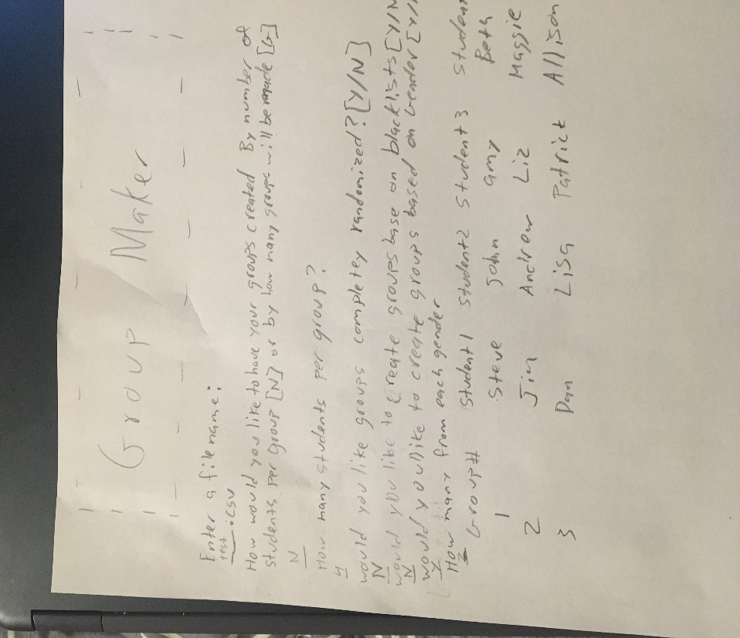

1. **Focus Group Feedback**

This section includes feedback from my focus group in regard to the interface diagram.

* 1. **Focus Group Feedback**
     1. Group Member A
* Easy to understand
* Matches the earlier paragraph
* Member A seemed to fully grasp the interface and thought that it matched the paragraph they read
  + 1. Group Member B
       - * Looked simple to learn
         * Member understood how the interface worked after a quick glance at the picture
    2. Group Member C
       - * Seemed easy to use
         * Member C said that they understood the general way the program’s interface worked
    3. Group Member D
       - * Not visually appealing
         * Follows the earlier paragraph
         * Member D said that they liked that it mimics the earlier paragraph
  1. **Reflection on feedback**

From the feedback I received, I can say that the interface matched the user model. The main adjustment that I would make would be to add some color. This is because, as Member D stated, the interface is not visually appealing. I would add color to the keywords that appear in the questions displayed to the user.

1. **Changes to Interface**

The main change added was the adding of color to the keywords that appear in the questions displayed to the user. The color was added in with little side notes due to lack of colored writing instruments.

